**Day :- 01 23/01/2025**

**Hands-On Workshop on Building Dynamic Web Applications Development.**

* **DATA BASE**
  + **My SQL**
  + **SQL**

A database is an organized collection of data that is stored, managed, and accessed electronically. It allows users to efficiently store, retrieve, modify, and manage information. Databases are widely used in various applications, from websites and mobile apps to enterprise systems, to handle structured or unstructured data.

### **Key Features of a Database**

1. Data Organization:
   * Information is stored in structured formats, often as tables, with rows (records) and columns (fields).
   * Examples: Spreadsheets, relational databases, or key-value pairs.
2. Data Management:
   * A database ensures data integrity, consistency, and security while supporting various operations like insertion, deletion, updating, and querying.
3. Centralized Storage:
   * Databases provide a centralized location for storing data, making it accessible to multiple users or applications.
4. Scalability and Performance:
   * Designed to handle large volumes of data efficiently and scale with growing data needs.

### **Types of Databases**

1. Relational Databases (RDBMS):
   * Organize data into tables with predefined relationships.
   * Use SQL (Structured Query Language) for querying and managing data.
   * Example: MySQL, PostgreSQL, Microsoft SQL Server.
2. NoSQL Databases:
   * Store unstructured or semi-structured data in formats like key-value pairs, documents, or graphs.
   * Suitable for handling big data and high-speed operations.
   * Example: MongoDB, Cassandra, Redis.
3. Hierarchical Databases:
   * Use a tree-like structure for data organization.
   * Example: IBM Information Management System (IMS).
4. Object-Oriented Databases:
   * Store data as objects, similar to object-oriented programming concepts.
   * Example: ObjectDB.
5. Cloud Databases:
   * Hosted on cloud platforms, allowing for scalability and remote access.
   * Example: Amazon RDS, Google Cloud SQL.

### **Common Database Operations**

1. Create: Add new data (e.g., CREATE command in SQL).
2. Read: Retrieve data (e.g., SELECT command in SQL).
3. Update: Modify existing data (e.g., UPDATE command in SQL).
4. Delete: Remove data (e.g., DELETE command in SQL).

### **Why Use a Database?**

* Data Storage: Efficiently store large amounts of data.
* Data Retrieval: Quickly retrieve information using queries.
* Security: Protect sensitive information with authentication and encryption.
* Data Sharing: Enable multiple users or applications to access data concurrently.
* Scalability: Grow with increasing data and user demands.

### **Example of Database Use**

1. E-commerce Websites: Store product details, user profiles, and orders.
2. Banking Systems: Maintain account details and transaction history.
3. Healthcare: Store patient records and appointment schedules.
4. Education: Manage student information and academic records.

Site That Learn

**<** [**https://www.altexsoft.com/blog/nosql-databases/**](https://www.altexsoft.com/blog/nosql-databases/) **>**

**What Is Object?**

**What Is Relational DataBase ?**

**What Is Status ?**

=> Active , Inactive

**Differentiate between Primary Key & Unique Key**

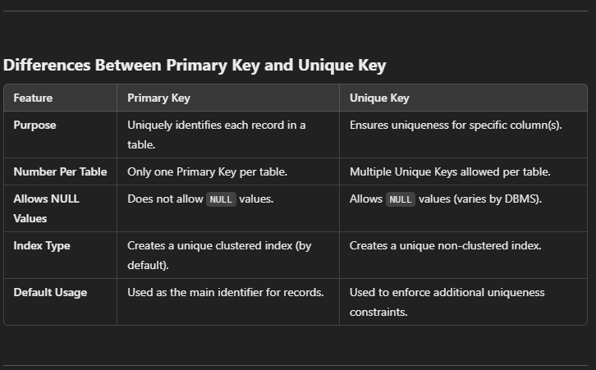

**What Is SQL?**

=>

**Table Of Database**

**=>**

**What is Alternate key**

**What is Candinate Key**

**What is Super Key**

**Types Of Keys**

1. Primary Key (PK)
2. Foreign Key (FK)
3. Unique Key
4. Composite Key
5. Candidate Key
6. Alternate Key
7. Super Key

**ACID Property :-**

Relational databases support **ACID (Atomicity, Consistency, Isolation, Durability)** properties that guarantee data accuracy and consistency even in cases of system failure.

* ***Atomicity*** ensures that all operations within a transaction are treated as a single unit—if one operation fails, the entire transaction fails.
* ***Consistency***ensures that transactions adhere to the rules of the database and bring it from one valid state to another.
* ***Isolation***ensures that transactions are processed independently of each other.
* ***Durability*** ensures that once a transaction is completed, it will persist even in the event of a system crash.

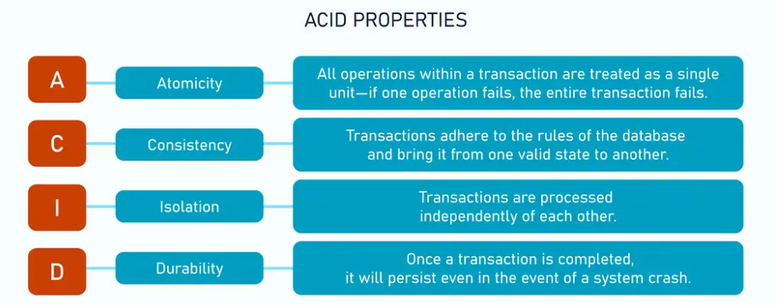

**What Is** [**customer relationship management**](https://www.altexsoft.com/blog/hotel-crm/) **(CRM)**

## **Key-value databases: Redis, Memcached, RocksDB, Hazelcast, Valkey**

**What Is Mongoes ?**

It seems like you're referring to **Mongoose**, which is an **Object Data Modeling (ODM)** library for **MongoDB** and **Node.js**.

**What Is Sequalized ?**

**Sequelize** is a **promise-based Object-Relational Mapping (ORM)** library for **Node.js** that allows you to interact with SQL databases such as **MySQL**, **PostgreSQL**, **SQLite**, and **Microsoft SQL Server** using JavaScript or TypeScript.

**What Is Firebase Firestore ?**

**What Is Documents ?**

### 

### **Graph database**

**Сolumn-oriented (or wide-column) databases**

**< https://docs.google.com/document/d/1Pzpkj_36BXWql9pQpu16Z_SCpnoMGW4L829VWDZ5DRQ/edit?tab=t.0 >**

**Create query to find all documents name united state**

[**https://cloud.mongodb.com/v2/6791f9e83efe8a18c88467a3#/overview?automateSecurity=true**](https://cloud.mongodb.com/v2/6791f9e83efe8a18c88467a3#/overview?automateSecurity=true)